AIVOA – Round 1 AI Product Engineer (Interns)

AI-Powered Customer Complaint Management System
Company Website: https://aivoa.ai

Objective
Build an AI-powered Customer Complaint Management System for the pharmaceutical manufacturing industry using the reference UI and demo video provided.

Before You Start
Before implementation, please:
- Watch the demo video completely.
- Read this assignment document.
- Research Quality Management System (QMS) used by pharmaceutical companies manufacturing API and FDF.
- Understand the purpose of the Customer Complaint module in a QMS.

Mandatory Technology Stack
- Frontend: React UI with Redux for state management.
- Backend: Python with FastAPI.
- AI Agent Framework: LangGraph.
- LLMs: Utilize Groq(https://console.groq.com/docs/models), specifically the gemma2-9b-it model (assume you will create a new API token for this). You may also consider llama-3.3-70b-versatile for context.
- Database: MySQL/Postgres SQL
- Font: Google Inter.

Reference Material
Demo Video: https://drive.google.com/file/d/1av2lzDPx8YMSzTrIz7w51HTRWBz3_5Nj/view?usp=sharing
Video Transcript: :13
left is the log customer complaint form and on the right is the AIVOA co-pilot
0:19
AI assistant. Important note, you must not fill the left form manually.
0:25
Instead, use the AI assistant on the right to fill and update the left form.
0:30
As part of this challenge, you need to implement the following mandatory AI
0:34
tools. The first tool is the log complaint tool. This works similarly to
0:39
chat GPT. You simply give a prompt to the AI assistant. For example, Apollo
0:45
Pharmacy reported discolored capsules in a moxicylin capsules 500 mg. The AI
0:52
should understand the prompt, extract the complaint details and automatically
0:56
populate the log customer complaint form. For example, it should fill fields
1:00
like product name as amoxicylin capsules, product strength as 500 mg,
1:06
batch number, manufacturing date, expiry date, and all other relevant complaint
1:12
details. Along with this, the AI should also use its own reasoning to populate
1:18
the AI co-pilot risk assessment section. For example, it may classify the
1:23
severity as major, suggest the next action as route to QA investigation and
1:29
issue replacement and generate other relevant risk assessment details based
1:33
on the complaint. The next tool is edit complaint tool. For example, sorry, the
1:39
batch number is BMX24602 and the affected quantity is 48
1:45
capsules. The AI should update both the log customer complaint form and the AI
1:50
co-pilot risk assessment while preserving all other complaint
1:54
information. The next tool is document extraction tool. You may create your own
1:59
sample customer complaint PDF or email using realistic pharmaceutical
2:04
manufacturing data to demonstrate this feature. When the document is uploaded,
2:08
the AI should extract the complaint details, populate the log customer
2:13
complaint form. For example, the AI may extract information from the PDF such as
2:19
product name, Metformin hydrochloride API, product strength/grade,
2:24
IP/BP, batch/lot number, MFH260712A,
2:32
and other relevant complaint details. also populate the AI co-pilot risk
2:37
assessment section as well based on reasoning. Even after extraction, you
2:42
should be able to modify the complaint using natural language. For example,
2:47
sorry, the batch number is CHG260712A and affected quantity is 50 kg 2 HDP
2:56
drums. It will update the left form accordingly like the batch number and
3:01
quantity. Thank you and we look forward to your submission.

Reference UI Screenshot

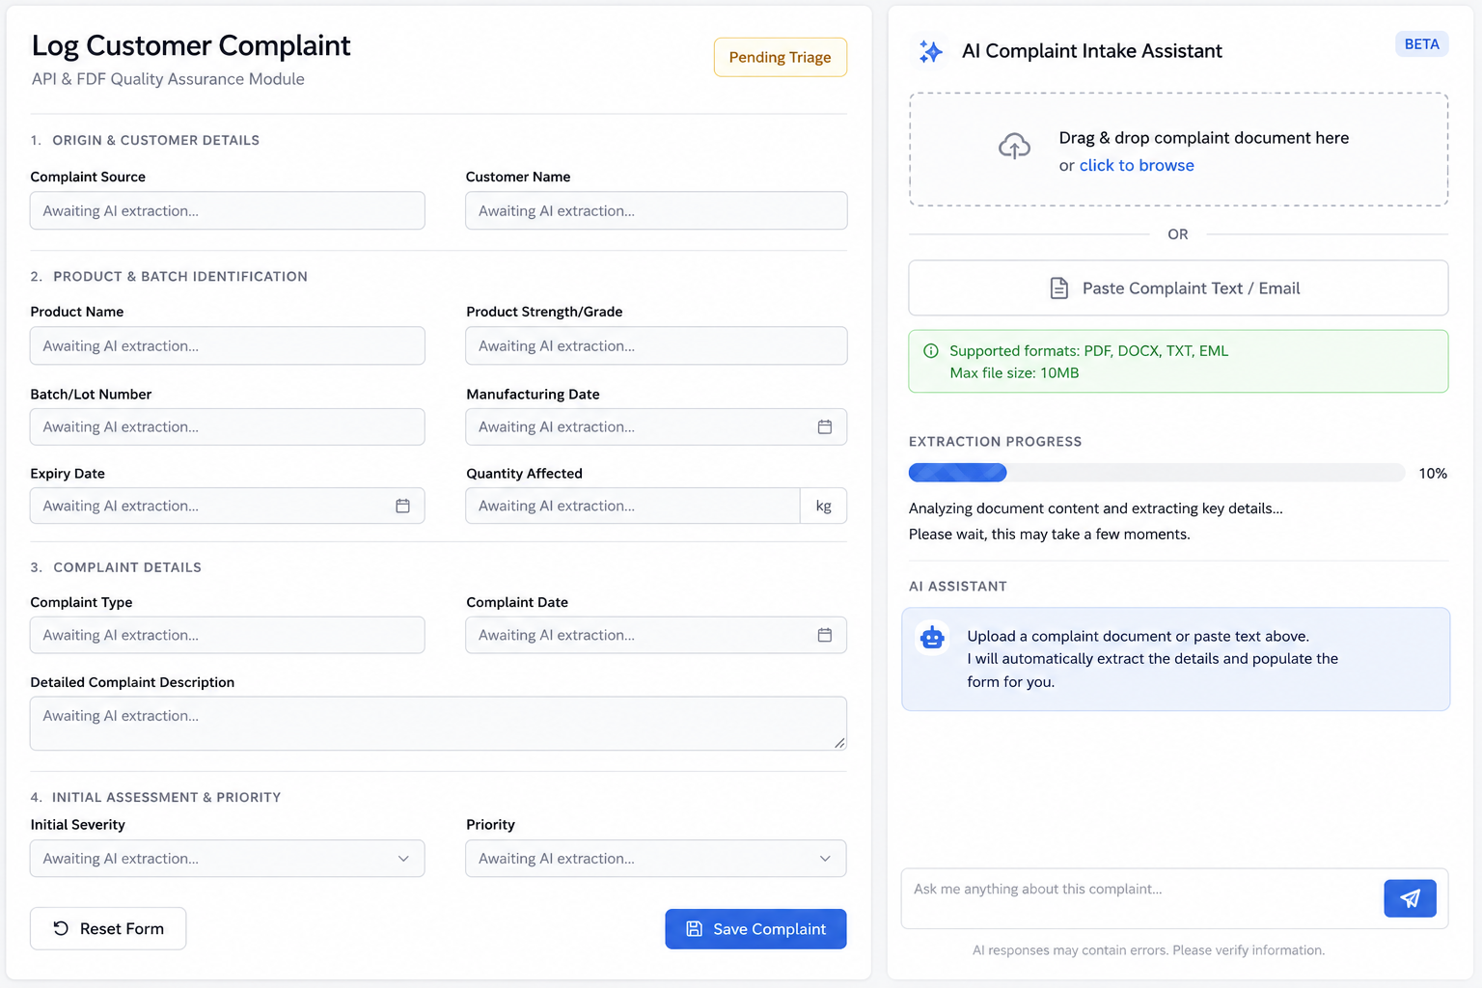

Implementation
- Follow the workflow demonstrated in the demo video.
- Use the mandatory technology stack.
- The UI doesn't need to match the screenshot exactly, but the demonstrated functionality should be implemented.
- You may create your own realistic pharmaceutical complaint PDFs, emails, or images for demonstration.
- Production-grade OCR or document parsing is not required.

Bonus Features (Optional)
Additional AI features are highly appreciated.
Examples:
- Complaint Completeness Checker
- Root Cause Recommendation
- Duplicate Complaint Detection
- CAPA Recommendation
- Complaint Summary
- AI Risk Classification

Deliverables
Submit your assignment using the link below:
Submission Form:
https://forms.gle/jdbgLTnuS6EAMSAP6
Include:
- GitHub Repository
- 5–10 minutes demo video explaining:(2 video submission)
  - Working demonstration of all implemented AI tools and frontend features.
  - Demonstrate and explain the code by walking through the complete end-to-end workflow, starting from the user's input (prompt or PDF/email upload) in the frontend, showing the relevant frontend code, API endpoints, backend processing, AI/LangGraph workflow, and finally how the response populates the Log Customer Complaint form and AI Copilot Risk Assessment.

Important Notes
- AI tools such as ChatGPT, Gemini, Claude, GitHub Copilot, Cursor, Windsurf, or similar tools are allowed and encouraged.
- Do not simply copy and paste AI-generated code. Understand what the code does, then implement and adapt it to match the workflow shown in the demo.
- During the interview, you should be able to explain your implementation and may be asked to modify or extend your solution.
- We value curiosity, clean code, product thinking, and problem-solving more than building a perfect application.

Good Luck!
We look forward to seeing your creativity and engineering skills.
Team AIVOA

